The Development of Eating Disorders in College-Aged Students: The Role of Motivation and Eating Abnormalities

Andrea M. Peterson¹
¹ Grace College, Winona Lake, USA

Abstract
Precursors for eating disorders have been studied extensively throughout the past 30 years. Known precursors are widely varied and can usually be tested via questionnaire. The present exploratory study sought to analyze the correlation between motivational styles of eating (using the “Motivations to Eat” survey) and disordered eating (using the Million Behavioral Medicine Diagnostic) in college-aged students (N=85). Statistically significant data suggests the motivational styles of eating of coping and compliance could be precursors to eating disorders. These findings, however, were limited by the lack specificity of the diagnostic category for disordered eating in the Million Behavioral Medicine Diagnostic.
Keywords: eating disorders, college students, motivational styles of eating

1. Introduction
Eating disorders (EDs) are an increasingly prevalent topic within psychological literature (Hoek & Hoeken, 2003). Binge eating disorder, bulimia nervosa, and anorexia nervosa comprise of the most common EDs diagnosed today. Disordered eating, in general, can also consist of obsessions with body weight, body shape, and food (“Eating Disorders,” 2016). Anorexia nervosa has been found to be a prevalent diagnosis across the previous decades amongst young women. In the past decade alone, anorexia nervosa has increased in 15- to 19-year-old females, the most high-risk group for the disorder. In contrast, bulimia nervosa has been found to be decreasing in incidences in the past thirty years but is still more prevalent amongst females than males. The only disorder found to be more common in males than females is binge eating disorder (Smink, van Hoeken, & Hoek, 2012).
As found in the National Comorbidity Survey Replication conducted between February 2001 and April 2003 on adults over age 18, the median ages of onset for binge eating disorder and anorexia nervosa/bulimia nervosa are 21 years old and 18 years old, respectively. The overall prevalence rates were found to be 1.2% for binge eating disorder (1.6% among females and 0.8% among males) and 0.3% for bulimia nervosa (0.5% for females and 0.1% for males). Anorexia nervosa was found to have a lifetime prevalence of 0.6% in adults (0.9% for females and 0.3% for males) (“Eating Disorders,” 2017).
No one thing is the known cause for EDs, though there has been extensive research into possible predictors, precursors, or causes of EDs (e.g., Bowman, 1999; Culbert, Racine, & Klump, 2015; Juli, 2015; Garcia, Houy-Durand, Thibaut, & Dechelotte, 2009; Schwartz & Henderson, 2009; and Favaro et al., 2007). Many predictors for EDs/disordered eating have been identified to be outside of the person’s control. For instance, Ruge and Londoño-Pérez (2017) found that if one or both of a person’s parents have a risk for EDs, it is likely that their child may also. They also found that a person’s height and age may likely act as risk factors for EDs. Further, Provost (1989) also identified that a person’s age may act as a predictor for developing EDs, as the author found that certain Eds were more problematic and prevalent from the ages of 18 to 22 years old.
Many studies have identified weight as a precursor for EDs. As early as the late 1980s, Striegel-Moore, Silberstein, Frensch, and Rodin (1989) found that a significant number of the first-year college students they studied (25%) put themselves on a diet for the first times in their lives. Further, the researchers found that, of the females studied, 15% began to binge eat for the first time during their first year of college. The overall findings suggest that when one has increased concern about weight, he or she subsequently increased their risk for EDs (Striegel-Moore et al., 1989). Since then, it has been documented in the literature that increased weight dissatisfaction and body image concerns act as links to developing EDs (Ruge & Londoño-Pérez, 2017; Killen, Taylor, Hayward, Wilson, Haydel, Hammer, Simmonds, Robinson, Litt, Varady, & Kraemer, 2006; Moyer, Dipietro, Berkowitz, & Stunkard, 1997). Hunger, particularly an increase in hunger, has also been found to act as a predictor to developing an ED (Stein, Kenardy, Wiseman, Dounchis, Arnow, & Wilfley, 2007).
Negativity has been established to act as a major precursor for EDs. Xie, Cai, He, Liu, & Liu (2016) found that in college students, if one has a negative coping style, it will mediate the effect of negative emotion, thus affecting emotional eating. Depression, negative self-esteem, and having an increased sense of ineffectiveness have all been found to be predictors of one developing EDs as well (Moyer et al., 1997; Gaines & Burnett, 2014; Striegel-Moore et al., 1989). Specifically, with binge eating behaviors, negative mood is a strong predictor of a pre-binge and is found to significantly increase post-binge (Stein et al., 2007).
Research has been conducted into pressure as being predictor for Eds as well. Peden, Stiles, Vandehey, & Diekhoff (2008) found in their study on the effects of pressure and competitiveness on EDs that disturbances in eating and body image are correlated with sociocultural pressures that make people feel as if they should look a certain way. Furthermore, they found that as societal and sociocultural pressures increased, so did psychological symptoms of EDs in the participants of the study (Peden et al., 2008). Further literature confirms the correlation of pressure and the development of an ED. Peer pressure has been proven to act as a predictor of dysfunctional eating (Gaines & Burnett, 2014). On college campuses, research has found that pressure to be thin and the pressure to complete developmental tasks have been significant predictors of EDs (Striegel-Moore et al., 1989; Provost, 1989).
Additionally, EDs have been found to differ based on gender and ethnicity. Disordered eating has been found to occur across all cultures (Cheng, Tran, Miyake, & Kim, 2017; Ruge & Londoño-Pérez, 2017). However, in a study examining ethnicity and sex as related to EDs, Hoerr, Bokram, Lugo, Bivins, and Keast (2013) found that 10.9% of females and 4.0% of males tested to be at risk for developing an ED; of those tested, 8.3% of African American females were found to be at risk. Keel, Fulkerson, and Leon (1997) found that for girls BMI and pubertal development acted as strong predictors of ED, whereas for boys, poor body image was the strongest predictor of disordered eating.
Three major theories have been proposed to affect the development of EDs. The first was proposed by Han and Kahn (2017), who researched Attachment Theory and disordered eating. Together, Han and Kahn discovered that attachment anxiety is associated with binge eating and attachment avoidance is associated with restricted eating. Further confirming their hypothesis, the authors found that 44% of college-aged females and 27% of college-aged males are on a diet; whereas 25-48% of college-aged females and 6-17% of college-aged males are at risk for developing an ED (Han & Kahn, 2017). The second theory presented was the Objectification Theory, which states that, according to Cheng et al. (2017), females feel pressure by culture to attain the ideal, sexual body; therefore, females are pressured into disordered eating. The third theory proposed in literature is hedonic hunger. In this theory, loss of control acts as the precursor to disordered eating. This loss of control concerning hunger can have the precursors of a person already being overweight or obese and the consumption of forbidden food. These, in combination with the freedom to access food and drink, can predict whether a person develops loss of control when eating (Lowe, Arigo, Butryn, Gilbert, Sarwer, & Stice, 2016).
The purpose of the present study was to examine the possible connection between EDs, motivational styles of eating, and personality in college students. The literature containing possible connections between these was noticeably lacking for college-aged populations, especially as most research focused on college students who participated in athletics. Given the past research, it was hypothesized that individuals who struggle with negative emotions such as depression or anxiety and use eating to cope or who have more compliant personalities are more likely to demonstrate disordered eating. It was also hypothesized that those who eat for pleasure or to engage socially and have lower needs for social approval are less likely to demonstrate disordered eating.

2. Method
2.1 Subjects
Research participants were 85 undergraduate students at a rural private college in the Midwest (27 males, 58 females), whose participation in the study counted as extra credit towards any behavioral science course they were taking. Subjects were recruited via word of mouth and syllabi. The average age of the subjects was 19.259 years old (SD = 1.285).
2.2 Procedure
This study was conducted through a combination of survey and experimental research. Subjects participated in a single session lasting from 30 to 60 minutes (depending on independent times to complete all materials necessary), in groups ranging from one to 30 persons. All data was collected by the student investigator. The study was approved prior to its conduction by the college’s Institutional Review Board.
Once gathered in groups, the students were given a consent form, which was then read to them in full by the examiner either in a classroom or in the research lab on campus. The examiner asked if there were any questions concerning the consent form so as to ensure that all subjects had full understanding of the consent form before signatures were obtained. Once complete, subjects submitted signed consent to the examiner.
A basic questionnaire was then distributed, collecting subjects’ ages, sex, and ethnicities. Once finished by all, subjects were asked to complete the survey and Million Behavioral Medicine Diagnostic® (MBMD). The examiner was present during distribution of all materials and communicated that if the participants had any questions about the wording of either the survey or the MBMD, they could ask the examiner for clarification at any time.
Once they completed all the materials, the subjects were provided with a description of the study and its purposes, as they were told the results of the study would be available upon request.
2.3 Measures/Materials
The survey, entitled “Motivations to Eat,” was used from the Journal of Personality Assessment by Jackson, Cooper, Mintz, & Albinod (2003). The survey consists of twenty questions, answered on a scale from 1 to 5, 1 being never/almost never to 5 being always/almost always. The scales are presented with questions concerning how often one eats resulting from varied reasons. The researchers developed and tested this survey based on parallel research done with motivations of alcohol use and concluded that there were four motivations to eat: compliance, coping, pleasure, and social motivations (Jackson et al., 2003). These were proven to be significant across genders (Jackson et al., 2003); hence, the examiners thought this a valid method to measure motivations of eating in the subjects.
The MBMD (MBMD®; Millon, Antoni, Millon, Minor, & Grossman, 2001) was developed to evaluate an all-inclusive collection of behavioral and psychosocial factors that can influence medical treatment results and illness adjustment (Creuss, Penedo, Benedict, Lattie, Molton, Kinsinger, Kava, Manoharan, & Soloway, 2013). The MBMD contains 165 true or false questions that takes around 20 or 30 minutes to complete. The test was validated by a heterogenous sample consisting of 700-plus patients, aged 18 to 85. These patients had a variety of conditions, ranging from cancer to HIV/AIDS. The study resulted in the validation of the MBMD being internally reliable, stable, having very good construct, and having convergent validity (Millon et al., 2001).
The examiner scored, inputted, and ran all statistics using Minitab-18. MBMDs were hand-scored by the examiner as well.
3. Results
Correlational statistics were calculated between the results of the “Motivations to Eat” survey and MBMD, with each category in the latter that had a non-numerical result being translated into a numerical identifier (i.e. 0 for unlikely problem area, 1 for possible problem area, and 2 for likely problem area). The scores were averaged per category and entered into Minitab-18 as such. The resulting correlations can be seen in Table 3.1.1.
3.1.1 Correlational Results
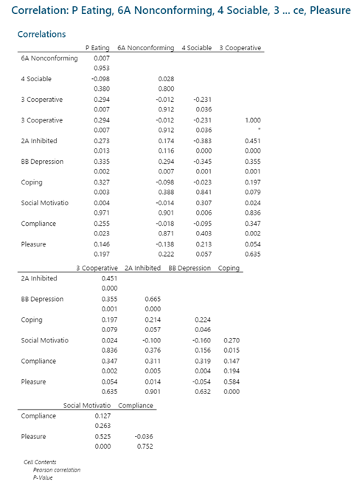
3.2.1 Summary Report for P Eating
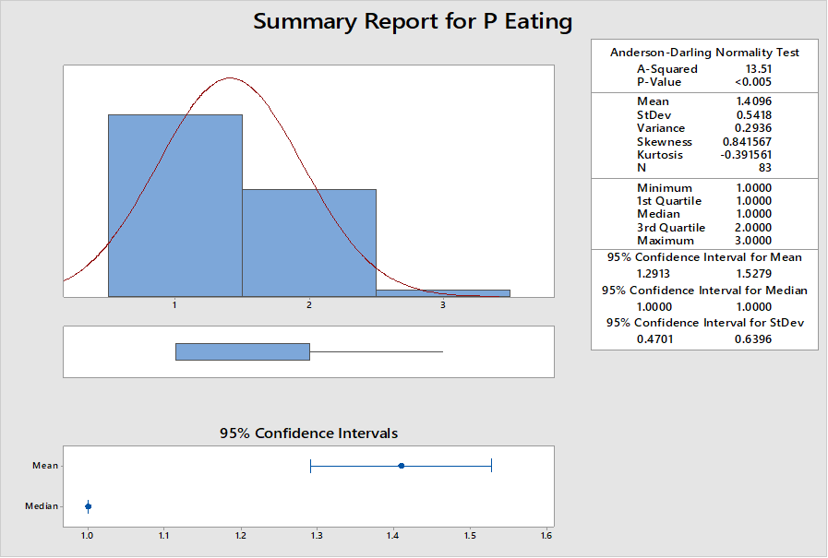
As disordered eating was the focus of this study, the P-Eating MBMD category’s correlations were examined extensively. It was found that P-Eating may be statistically significant in relation to the MBMD categories of 3-Cooperative (p-value of .007), 2A-Inhibited (p-value of .013), and BB-Depression (p-value of .002). Further, P-Eating was found to be statistically significant via correlation to the survey’s categories of coping (p-value of .003) and compliance (p-value of .023). The summary report for P-Eating can be seen in Graph 3.2.1
Additional statistically significant correlation was found between the 4-Sociable MBMD category and the survey’s social motivation (p-value of .006), in addition to the MBMD’s 3-cooperative and the survey’s compliance (p-value of .002).
4. Discussion
Is there a correlation between motivational styles of eating and the development of EDs in college-aged students? Our findings suggest that disordered eating and predictors of EDs were found to correlate with the scores of the MBMD categories of 3-Cooperative, 2A- Inhibited, and BB-Depression. These may expressly relate to P-Eating being statistically significant to the motivational styles of eating of coping and compliance. The results of this study suggest that there is a relationship between college-aged students who eat to cope with negative affect and/or eat in order to comply with others’ expectations, and an increase in the likelihood of the development of disordered eating. The findings also suggest that those who eat to be social (social motivation) and to enhance their own pleasure (pleasure) were found to be less at risk for EDs than those listed previously.
These findings both agree with and contradict the literature earlier mentioned. Concerning agreement, disordered eating with the motivational styles of coping and compliance directly reflect the influence of pressure on EDs. Eating to comply with peer pressure, cultural pressure, pressure for thinness, or pressure from objectification have been found to be precursors to many EDs (Peden et al., 2008; Gaines & Burnett, 2014; Striegel-Moore et al., 1989; Provost, 1989; Han & Kahn, 2017) align with the motivational styles of eating of coping and compliance; adding further support that these motivational styles of eating may be precursors to EDs. More so, eating to cope with negative affect directly relates with the previous research findings that negativity is a precursor for EDs.
From the literature, one would likely postulate that those who had the motivational style of eating of pleasure may have caused them to test for disordered eating. This idea would come from the Hedonic Theory (Lowe et al., 2016), which correlates disordered eating to loss of control. Although the pleasure category was not directly developed to describe loss of control (Jackson et al., 2003), it can be assumed this motivational style would be most likely to correlate with binge behavior other than coping. However, the present study found the opposite to be true.
This exploratory study’s results suggest that a person may be more at risk to develop EDs based on their motivational style of eating. It is thus recommended that students learn to recognize their motivation to eat in order to seek help if needed. In addition to the precursors found in literature listed earlier, it is important to recognize potential problem behaviors prior to the development of EDs. As Jackson et al. (2003) noted, each motivation to eat can potentially predict restrictive eating, bingeing, and purging. As such, it is important to examine these.
4.1 Limitations
The data from the MBMD and “Motivations to Eat” were calculated by hand. As a result of this, there is likelihood that there were errors in data entry and calculations put into Minitab-18 by the examiner. Further, analysis of race and gender (and their effects on the data) were not calculated. This could have left out important information needed for analysis. Additionally, the population presented in this study all attended one private, rural college. The presenting sample had a dominant ethnicity of “white.” This could present a biased population that cannot be generalized outside of this environment.
Moreover, the diagnostic category of P-Eating presented in the MBMD lacks specificity as to which ED for which the person is at risk for. This leaves a gap in the results as to which ED found to be statistically significant to coping and compliance. The study also lacked strict adherence to the scientific method, thus no data found are absolute but rather suggest a relationship among these factors. Future studies should be conducted to validate the results presented.

4.2 Suggestions for Future Research
It is important that health and psychology researchers continue to examine potential risks and correlations for EDs. This study lacked identification of disordered eating behavior beyond P-Eating on the MBMD. It is suggested that the motivational styles of eating be compared to specific disorders rather than a general diagnostic; this could result in more accurate data. Further, it is suggested that research be conducted in a more diverse population to obtain a more generalizable result to determine which style of eating affects disordered eating.
4.3 Suggestion for College-Aged Students
Many precursors and predictors have been found for the development of EDs in college-aged students. The present study found that when people eat to cope with negative affect and to comply with the expectations of others, they are more at risk for the development of an ED. These confirm previous findings in literature and help to detect self-identification measures than can make a student more aware of their risk. It is important for students to examine their motivational style of eating to give them the best chance of healthy eating, rather than problematic eating that can lead to the development of an ED.
References
- Cheng, H.-L., Tran, A. G. T. T., Miyake, E. R., & Kim, H. Y. (2017). Disordered eating among Asian American college women: A racially expanded model of objectification theory. Journal of Counseling Psychology, 64(2), 179–191. https://doi.org/10.1037/cou0000195
- Cruess, D. G., Penedo, F. J., Benedict, C., Lattie, E. G., Molton, I., Kinsinger, D., … Soloway, M. (2013). Millon Behavioral Medicine Diagnostic (MBMD) predicts health-related quality of life (HrQoL) over time among men treated for localized prostate cancer. Journal of Personality Assessment, 95(1), 54–61.
- Eating Disorders. (2016). Retrieved April 24, 2018, from https://www.nimh.nih.gov/health/topics/eating-disorders/index.shtml
- Gaines, S. A., & Burnett, T. B. S. (2014). Perceptions of eating behaviors, body image, and social pressures in female division ii college athletes and non-athletes. Journal of Sport Behavior, 37(4), 351–369.
- Han, S., & Kahn, J. H. (2017). Attachment, Emotion Regulation Difficulties, and Disordered Eating Among College Women and Men. The Counseling Psychologist, 45(8), 1066–1090. https://doi.org/10.1177/0011000017744884
- Hoerr, S. L., Bokram, R., Lugo, B., Bivins, T., & Keast, D. R. (2002). Risk for Disordered Eating Relates to both Gender and Ethnicity for College Students. Journal of the American College of Nutrition, 21(4), 307-314. doi:10.1080/07315724.2002.10719228
- Jackson, B., Cooper, M., Mintz, L., & Albinod, A. (2003). Motivations to eat: Scale development and validation (Vol. 37). https://doi.org/10.1016/S0092-6566(02)00574-3
- Killen Joel D., Taylor C. Barr, Hayward Chris, Wilson Darrell M., Haydel K. Farish, Hammer Lawrence D., … Kraemer Helena. (2006). Pursuit of thinness and onset of eating disorder symptoms in a community sample of adolescent girls: A three‐year prospective analysis. International Journal of Eating Disorders, 16(3), 227–238. https://doi.org/10.1002/1098-108X(199411)16:3<227::AID-EAT2260160303>3.0.CO;2
- Keel, P.K., Fulkerson, J.A. & Leon, G.R. (1997). Disordered Eating Precursors in Pre- and Early Adolescent Girls and Boys. Journal of Youth and Adolescence, 26, 203-216. https://doi.org/10.1023/A:1024504615742
- Lowe, M. R., Arigo, D., Butryn, M. L., Gilbert, J. R., Sarwer, D., & Stice, E. (2016). Hedonic hunger prospectively predicts onset and maintenance of loss of control eating among college women. Health Psychology, 35(3), 238-244. doi:10.1037/hea0000291
- Millon T, Antoni MH, Millon C, Meagher S, Grossman S. Test manual for the Millon Behavioral Medicine Diagnostic (MBMD) Minneapolis, MN: National Computer Services; 2001.
- Moyer, D. M., Dipietro, L., Berkowitz, R. I., & Stunkard, A. J. (1997). Childhood sexual abuse and precursors of binge eating in an adolescent female population. International Journal of Eating Disorders, 21(1), 23-30. doi:10.1002/(sici)1098-108x(199701)21:13.0.co;2-5
- NIMH » Eating Disorders. (2017). Retrieved April 25, 2018, from https://www.nimh.nih.gov/health/statistics/eating-disorders.shtml
- Peden, J., Stiles, B. L., Vandehey, M., & Diekhoff, G. (2008). The effects of external pressures and competitiveness on characteristics of eating disorders and body dissatisfaction. Journal of Sport & Social Issues, 32(4), 415-429. doi:10.1177/0193723508325638
- Provost, J. A. (1989). Eating disorders in college students. Psychiatric Medicine, 7(3), 47–58. Retrieved from http://europepmc.org/abstract/med/2813831
- Ruge, A. M. M., & Londoño-Pérez, C. (2017). Family and personal predictors of eating disorders in young people. Anales de Psicología, 33(2), 235–242.
- Smink, F. R. E., van Hoeken, D., & Hoek, H. W. (2012). Epidemiology of Eating Disorders: Incidence, Prevalence and Mortality Rates. Current Psychiatry Reports, 14(4), 406–414. https://doi.org/10.1007/s11920-012-0282-y
- Stein Richard I., Kenardy Justin, Wiseman Claire V., Dounchis Jennifer Zoler, Arnow Bruce A., & Wilfley Denise E. (2007). What’s driving the binge in binge eating disorder?: A prospective examination of precursors and consequences. International Journal of Eating Disorders, 40(3), 195–203. https://doi.org/10.1002/eat.20352
- Striegel-Moore, R. H., Silberstein, L. R., Frensch, P., & Rodin, J. (1989). A prospective study of disordered eating among college students. International Journal of Eating Disorders, 8(5), 499-509. doi:10.1002/1098-108x(198909)8:53.0.co;2-a
- Xie, A., Cai, T.-S., He, J.-B., Liu, W.-L., & Liu, J.-X. (2016). Effects of negative emotion on emotional eating of college students’: Mediating role of negative coping style. Chinese Journal of Clinical Psychology, 24(2), 298–301.

